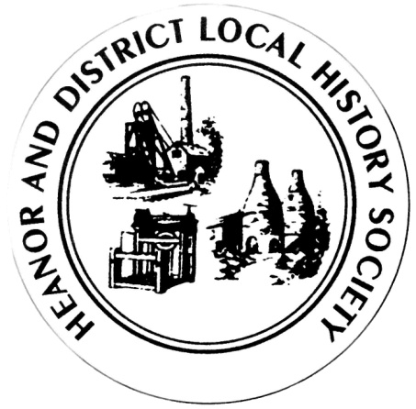
We want your memories! As part of an ongoing project, the Heanor & District Local History Society wants to hear from YOU.
We would like to establish a collection of people’s memories about the area - it can be from any period, and from any part of the district. And ANY subject - whether home life, work life, shopping, leisure. It doesn’t matter how trivial you may think your reminiscences are, they will help form part of a much bigger picture, which we can use to assist our future research, publications and newsletters.
This is nothing new of course; we have always asked for this from our members, but have now decided to use this method to try to prompt people to give information on specific issues.
So, every couple of meetings (if it works), we will distribute a new form, on a different topic, and with different questions. There is no deadline. You don’t have to take part in all, or any, of the topics. Likewise, you don’t have to be a member to take part - all that we ask is that it is something to do with the Heanor area, or which involved Heanor people. If you can think of someone else who may like to help, please feel free to pass a form onto them.
This month’s topic is: Shops.
How to share your memories with us:
- If you normally attend our meetings, just fill in the form and hand it back at the next meeting.
- If you don’t attend our meetings, then please send us an email with the information (mail@heanorhistory.org.uk).
We would rather that you didn’t send us information anonymously, but nobody’s name will be published unless you have specifically given us permission to do so. In particular, we WILL NOT publish anything which of a personal or potentially sensitive nature.
Name | Address
Telephone
Email address
Are you willing for your name to be linked to any information supplied? |  | Yes / No
Would you be prepared to discuss this or related information further? |  | Yes / No

P.T.O.

Please think of one particular shop in the Heanor area which you can remember really well….
What was the name of the shop?
What did they sell?
Where was the shop?
Roughly when do you recall it from?
What do you remember about the shop front?
What was it like inside?
Who were the owners/staff who you remember?
What was special or memorable about it? Is there a particular incident or event which sticks in your mind?
Please use a separate sheet if necessary.
We would particularly like to hear more if you worked there.
And we are really keen to obtain copies of any old photographs of shops (or anything else!) – we’ll happily do a copy and return the original to you.
If you would like to repeat the questions for another shop, please do so on a blank sheet.
Thank you

